# Discover and Understand Details 2

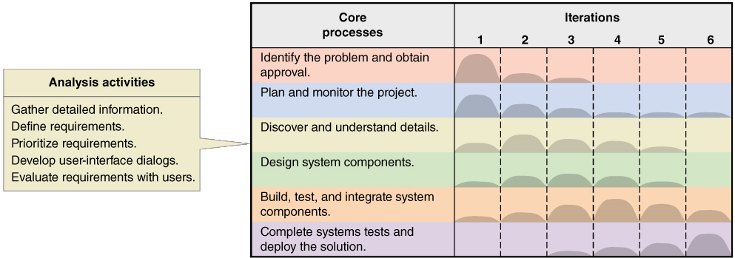

Working in teams, complete the following tasks:

1. Domain Model Class Diagram Primer
   1. Sketch a simple Domain Model Class diagram that shows a team has one or more players and each player is on one and only one team. List appropriate attributes for each class.



Components of a Class

Example Domain Model Class Diagram

* 1. Extend the Domain Model Class diagram for teams and players about to show a record of game statistics for each player in each game. (Hint: use an association class.)
  2. Implement your Domain Model Class diagram using Lucidchart (or your nominated drawing software).

1. Devise Your Own Domain Model Class Diagram
   1. Use the Brainstorming Technique (refer to the lecture slides and textbook) to identify “things in the problem domain” for your chosen subsystem from Lab 3.

Example of the Brainstorming Technique

* 1. Develop a Domain Model Class diagram to model the information you identified.
  2. Implement your Domain Model Class diagram using Lucidchart (or your nominated drawing software).

1. Work on your assignment.